KJSCE/IT/TYBTECH/SEMV/WP-II/2021-22

**Experiment No. 1** 

**Title:** Simple PHP programs using Conditional Constructs

(Autonomous College Affiliated to University of Mumbai)

KJSCE/IT/TYBTECH/SEMV/WP-II/2021-22

**Batch: B1 Roll No.: 1914078 Experiment No.:1**

**Aim:** Write PHP programs using various conditional constructs .

**Resources needed:** Windows OS, Web Browser, Editor, XAMPP Server

**Pre Lab/ Prior Concepts:**

Students should have prior knowledge of HTML/CSS/Basic Programming.

**Theory:**

**PHP**

1. PHP is a server side scripting language.

2. It can be used to develop Static websites or Dynamic websites or Web applications. 3. PHP stands for Hypertext Pre-processor, that earlier stood for Personal Home Pages. 4. PHP scripts can only be interpreted on a server that has PHP installed. 5. The client computers accessing the PHP scripts require a web browser only. 6. A PHP file contains PHP tags and ends with the extension ".php". 

7. PHP code may be embedded into HTML code, or it can be used in combination with various web template systems, web content management system and web frameworks. **PHP Conditional Statements** 

**if statement** - executes some code if one condition is true

**if...else statement** - executes some code if a condition is true and another code if that condition is false

**if...elseif...else statement** - executes different codes for more than two conditions **switch statement** - selects one of many blocks of code to be executed

Sample Code: **if and if else example**

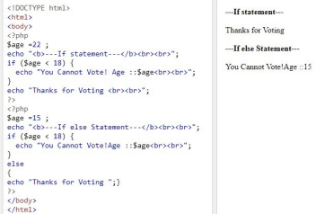(Autonomous College Affiliated to University of Mumbai)

KJSCE/IT/TYBTECH/SEMV/WP-II/2021-22

**Echo and Print**

echo and print are more or less the same. They are both used to output data to the screen. The differences are small: echo has no return value while print has a return value of 1 so it can be used in expressions. echo can take multiple parameters (although such usage is rare) while print can take one argument. echo is marginally faster than print.

We can use html tags in php e.g. <br>, <b> used in the above example.

**Procedure:**

**How to Run a PHP File in XAMPP?**

Step 1 : First Create PHP script using any editor like notepad, notepad++ etc. <?php echo "Welcome to the world of PHP."; ?>

Step 2 : Save file as following... firstProg.php

In C:xampp/htdocs/myproject/firstProg.php 

Start XAMPP Apache server (first time only) 

Step 3 : Run the PHP script

Open Your browser and write in

Type url : localhost/myproject/firstProg.php

**Output:**

**Welcome to the world of PHP.**

**Output(Code with result Snapshot)**

**Code:**

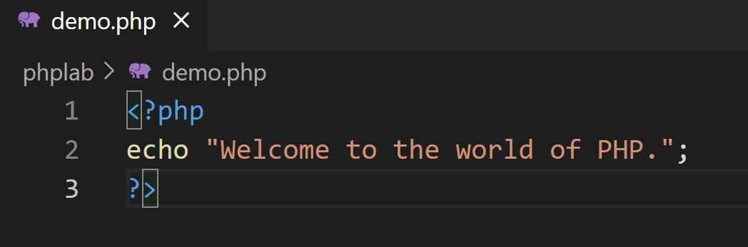

**Output:**

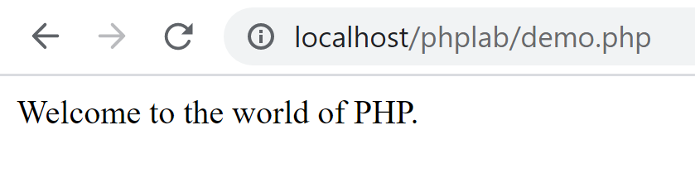

**Activity:**

**Code1:**

<?php

        $day = "1";

        switch ($day) {

            case "1":

                echo "It is Monday!";

                break;

            case "2":

                echo "It is today!";

                break;

            case "3":

                echo "It is Wednesday!";

                break;

            case "4":

                echo "It is Thursday!";

                break;

            case "5":

                echo "It is Friday!";

                break;

            case "6":

                echo "It is Saturday!";

                break;

            case "7":

                echo "It is Sunday!";

                break;

            default:

                echo "Invalid number!";

        }

    ?>

**Output:**



**Code2:**

<?php

        $num = 15;

        echo "<h3>Fibonacci series using recursive function:</h3>";

        echo "\n";

        function series($num){

            if($num == 0){

                return 0;

            }else if( $num == 1){

                return 1;

            }  else {

                return (series($num-1) + series($num-2));

            }

        }

        for ($i = 0; $i < $num; $i++){

            echo series($i);

            echo "\n";

        }

    ?>

**Output:**

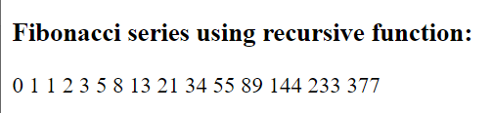

**Code3:**

<?php

        $limit = 100;

        $initial = 2;

        while(TRUE)

        {

            $div = 2;

            if($initial > $limit)

            {

                break;

            }

            while(TRUE)

            {

                if($div > sqrt($initial))

                {

                    echo $initial."  ";

                    break;

                }

                if($initial % $div == 0)

                {

                    break;

                }

                $div = $div + 1;

            }

            $initial = $initial + 1;

        }

    ?>

**Output:**



**Questions:-**

1. Explain Loops in PHP with example.
2. In PHP, we have the following loop types:

while - loops through a block of code as long as the specified condition is true

do...while - loops through a block of code once, and then repeats the loop as long as the specified condition is true

for - loops through a block of code a specified number of times

foreach - loops through a block of code for each element in an array

1. Why choose PHP over other programming languages?
2. The simplicity of coding, easy learning, and a faster approach makes PHP a lot better than the other complex programming languages. PHP is an open source language, making web development an efficient and more interactive task for the developers.

**Outcomes:** : Illustrate use of basic PHP concepts to develop applications



**Conclusion:** We wrote PHP programs using various conditional constructs .

**Grade: AA / AB / BB / BC / CC / CD /DD**

**Signature of faculty in-charge with date**

**References:**

**Books:**

1. Thomson PHP and MySQL Web Development Addison-Wesley Professional , 5th Edition 2016.

2. Peter MacIntyre, Kevin Tatroe Programming PHP O'Reilly Media, Inc, 4th Edition 2020 3. Frank M. Kromann Beginning PHP and MySQL: From Novice to Professional, Apress 1st Edition, 2018

(Autonomous College Affiliated to University of Mumbai)